What is AWS?
AWS is a cloud computing platform that provides on-demand services like compute, storage, databases, networking, and security.

What are the main AWS service categories?

Compute (EC2, Lambda)

Storage (S3, EBS)

Database (RDS, DynamoDB)

Networking (VPC, Route 53)

Security (IAM)

What is EC2?
Virtual servers in the cloud used to run applications.

What is S3?
Object storage service used for backup, static websites, logs, and media.

What is IAM?
Identity and Access Management – controls who can access AWS resources.

What is a Region and Availability Zone?

Region: Geographic area

AZ: Isolated data centers within a region

Types of cloud platforms
Public clouds are the most common type of cloud computing deployment. The cloud resources (like servers and storage) are owned and operated by a third-party cloud service provider and delivered over the internet. With a public cloud, all hardware, software and other supporting infrastructure are owned and managed by the cloud provider. Microsoft Azure , AWS ,GCP , is are example of a public cloud.
Advantages of public clouds:
- Lower costs—no need to purchase hardware or software and you pay only for the service you use.
- No maintenance—your service provider provides the maintenance.
- Near-unlimited scalability—on-demand resources are available to meet your business needs.
- High reliability—a vast network of servers ensures against failure.

A private cloud consists of cloud computing resources used exclusively by one business or organization. The private cloud can be physically located at your organization’s on-site datacenter or it can be hosted by a third-party service provider. But in a private cloud, the services and infrastructure are always maintained on a private network and the hardware and software are dedicated solely to your organization
Advantages of a private cloud:
- More flexibility—your organisation can customise its cloud environment to meet specific business needs.
- More control—resources are not shared with others, so higher levels of control and privacy are possible.
- More scalability—private clouds often offer more scalability compared to on-premises infrastructure.
A hybrid cloud platform gives organizations many advantages—such as greater flexibility, more deployment options, security, compliance and getting more value from their existing infrastructure. When computing and processing demand fluctuates, hybrid cloud computing gives businesses the ability to seamlessly scale up their on-premises infrastructure to the public cloud to handle any overflow—without giving third-party datacenters access to the entirety of their data.
.

Advantages of the hybrid cloud:
- Control—your organisation can maintain a private infrastructure for sensitive assets or workloads that require low latency.
- Flexibility—you can take advantage of additional resources in the public cloud when you need them.
- Cost-effectiveness—with the ability to scale to the public cloud, you pay for extra computing power only when needed.
- Ease—transitioning to the cloud does not have to be overwhelming because you can migrate gradually—phasing in workloads over time.
Virtualization will transfer hardware into software
Managed AWS till recent times was using the Xen hypervisor

IAAS PAAS SAAS

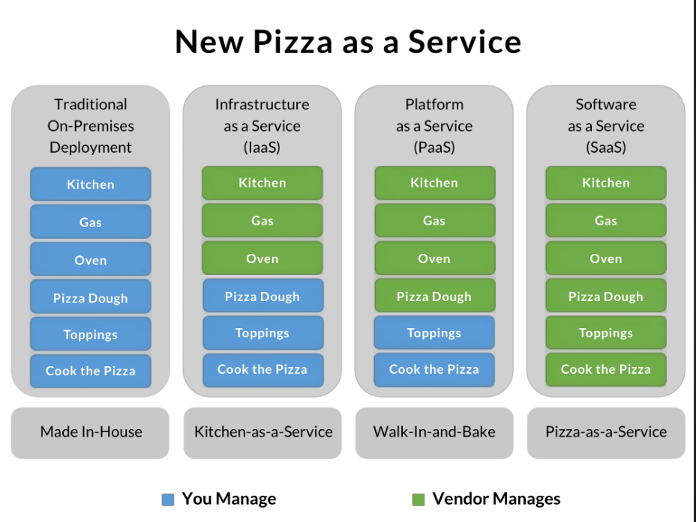

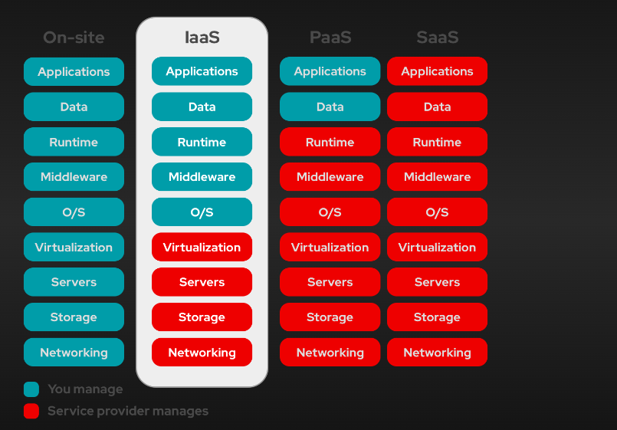

How is an IP Address Formed?
An IP address is just a number that follows a specific format.
IPv4 – The Most Common Type of IP Address
- An IPv4 address is made up of 32 bits (binary numbers of 0s and 1s).
- These 32 bits are split into 4 parts (called octets).
- Each octet contains 8 bits.
- It is written in decimal format (so humans can read it easily).

192.168.1.10 :
Octet4 Octet3 octet2 octet1
11000000.10101000.00000001.00001010

Decimal Binary Representation
192 11000000
168 10101000
1 00000001
10 00001010

Types of IP Addresses
- IPv4 (Internet Protocol version 4)
  - Formed using 32 bits (4 octets)
  - Written in dotted decimal notation (e.g., 192.168.1.1)
  - Each octet ranges from 0 to 255
  - Example: 172.16.254.1
- IPv6 (Internet Protocol version 6)
  - Formed using 128 bits (8 groups of 4 hexadecimal digits)
  - Written in colon-separated hexadecimal notation (e.g., 2001:0db8:85a3:0000:0000:8a2e:0370:7334)
  - Allows for a vastly larger number of unique addresses

Formation of an IP Address
An IP address consists of two main parts:
- Network Portion: Identifies the network to which the device belongs.
- Host Portion: Identifies the specific device (host) within that network.

Class | Starting IP | Ending IP | First Octet Range | Usage
Class A | 1.0.0.0 | 126.255.255.255 | 1 - 126 | Large networks (ISPs, big companies)
Class B | 128.0.0.0 | 191.255.255.255 | 128 - 191 | Medium-sized businesses
Class C | 192.0.0.0 | 223.255.255.255 | 192 - 223 | Small businesses & home networks
Class D | 224.0.0.0 | 239.255.255.255 | 224 - 239 | Multicast communication
Class E | 240.0.0.0 | 255.255.255.255 | 240 - 255 | Experimental & research

IP Class | IP Range | Subnet Mask | Network Part | Host Part | Example
Class A | 1.0.0.0 - 126.255.255.255 | 255.0.0.0 (/8) | First 8 bits (1st octet) | Remaining 24 bits (3 octets) | 10.5.25.3 (Network: 10, Host: 5.25.3)
Class B | 128.0.0.0 - 191.255.255.255 | 255.255.0.0 (/16) | First 16 bits (2 octets) | Remaining 16 bits (2 octets) | 172.16.5.25 (Network: 172.16, Host: 5.25)
Class C | 192.0.0.0 - 223.255.255.255 | 255.255.255.0 (/24) | First 24 bits (3 octets) | Remaining 8 bits (1 octet) | 192.168.1.50 (Network: 192.168.1, Host: 50)
Class D (Multicast) | 224.0.0.0 - 239.255.255.255 | N/A | N/A | N/A | N/A (Used for multicast communication)
Class E (Experimental) | 240.0.0.0 - 255.255.255.255 | N/A | N/A | N/A | N/A (Reserved for experimental use)

Class | IP Range | Default Subnet Mask | Network Bits | Host Bits | Number of Networks | Number of Hosts per Network
Class A | 1.0.0.0 - 126.255.255.255 | 255.0.0.0 (/8) | 8 bits | 24 bits | 128 | 1,67,77,214
Class B | 128.0.0.0 - 191.255.255.255 | 255.255.0.0 (/16) | 16 bits | 16 bits | 16,384 | 65,534
Class C | 192.0.0.0 - 223.255.255.255 | 255.255.255.0 (/24) | 24 bits | 8 bits | 20,97,152 | 254

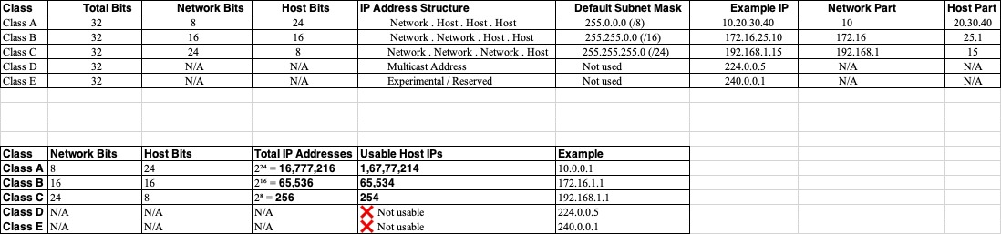

Subnet Masking is a technique used in networking to divide an IP address into two parts: the network part and the host part. This process helps in organizing and managing IP addresses more efficiently, particularly in larger networks.
- Network Part: Identifies the specific network to which the device belongs.
- Host Part: Identifies the specific device (or host) within that network
Subnet Mask is a 32-bit number, similar to an IP address, written in the same format (four octets). The '1' bits in the subnet mask represent the network portion, and the '0' bits represent the host portion.

Loopback Address
- Definition: A loopback address is a special IP address used for testing network connections on the local host (your own computer).
- Value: The most common loopback address is 127.0.0.1.

VPC

CIDR (Classless Inter-Domain Routing) is a method used to allocate IP addresses and route IP packets. A CIDR range is a notation for specifying IP addresses and their associated network mask.
In CIDR notation, an IP address is followed by a slash (/) and a number that represents the subnet mask. The subnet mask defines the size of the network and how many IP addresses are available in the network.
For example:
CIDR Block: 172.16.0.0/26
- 172.16.0.0 is the IP address.
- /26 indicates the subnet mask. This means that the first 26 bits are part of the network address, and the remaining 6 bits are available for host addresses within that network.

Total IP Range:
- The subnet mask is /26, which means the network has 32 - 26 = 6 bits for hosts.
- The number of IPs in a /26 subnet is 2^6 = 64 IPs.
However, two of these IP addresses are reserved:
  - Network Address (the first IP in the range)
  - Broadcast Address (the last IP in the range)
So, the usable IP addresses are 64 - 2 = 62 IP addresses.

Lets create 8 subnets, which means we need to borrow 3 more bits from the host portion (2^3 = 8 subnets).
This will give us a /29 subnet mask (26 + 3 = 29).
CIDR Block: 172.16.0.0/26

Subnets:
Subnet | Network Address | Usable IP Range | Broadcast Address
Subnet 1 | 172.16.0.0/29 | 172.16.0.1 to 172.16.0.6 | 172.16.0.7
Subnet 2 | 172.16.0.8/29 | 172.16.0.9 to 172.16.0.14 | 172.16.0.15
Subnet 3 | 172.16.0.16/29 | 172.16.0.17 to 172.16.0.22 | 172.16.0.23
Subnet 4 | 172.16.0.24/29 | 172.16.0.25 to 172.16.0.30 | 172.16.0.31
Subnet 5 | 172.16.0.32/29 | 172.16.0.33 to 172.16.0.38 | 172.16.0.39
Subnet 6 | 172.16.0.40/29 | 172.16.0.41 to 172.16.0.46 | 172.16.0.47
Subnet 7 | 172.16.0.48/29 | 172.16.0.49 to 172.16.0.54 | 172.16.0.55
Subnet 8 | 172.16.0.56/29 | 172.16.0.57 to 172.16.0.62 | 172.16.0.63

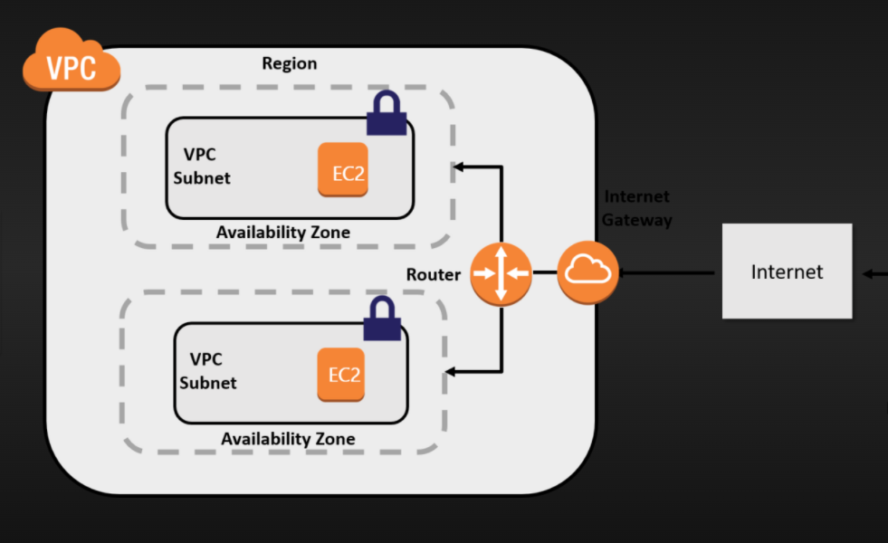

- What is VPC (virtual private cloud)?
It is a virtual network dedicated to your AWS account, it logically isolates from other virtual networks in the AWS cloud, and where you can launch your AWS instance.
VPC consist of subnets, internet gateway, nat gateway & Routing table.
- What is a subnet?
Subnet is a logical subdivision of IP network. The practice of dividing a network into 2 or more networks is called sub netting.

- What is Route table?
A set of rules called routes that are used to determine where network traffic is directed.

- What is Internet gateway?
A gateway that you attach to your VPC to enable communication between resources in your VPC and the internet.

- What is NAT gateway?
Lets private subnet instances access the internet (outbound only).
NAT Gateway is used to connect to the Internet from instances within a private subnet in the VPC.
Nat gateway will be created from public subnet and attach to the private subnet.

- What is VPC endpoint?
It enables you to privately connect your VPC to supported AWS services and VPC endpoint services powered by private link without requiring an internet gateway, NAT device, VPN connection or AWS direct connection.
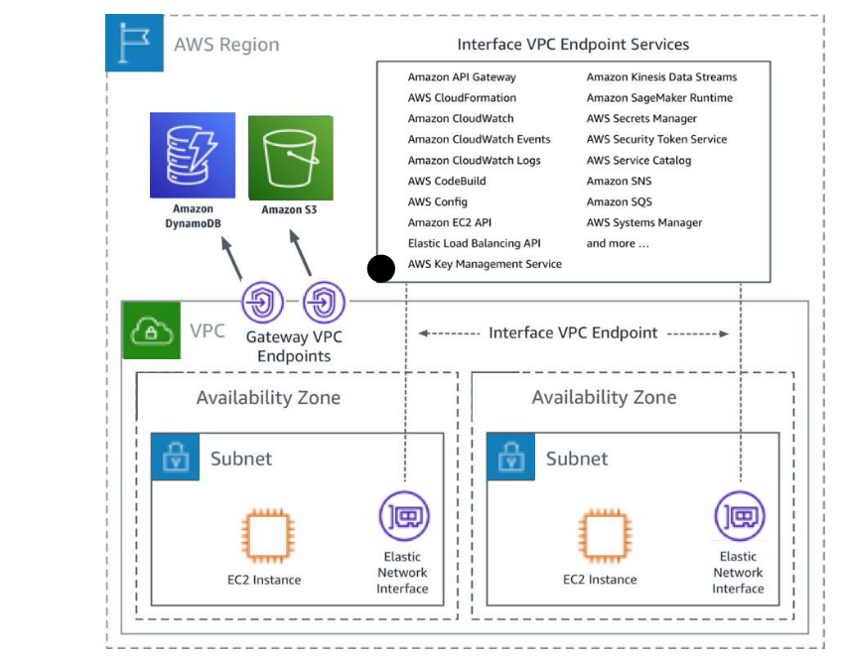

- What is NACL (Network ACL)? Network Access Control Lists
NACL are firewall at the subnet level.
- It is a stateless means that any changes made in the inbound rule will not reflect the outbound rule, i.e., you need to add the outbound rule separately. For example, if you add an inbound rule port number 80, then you also have to explicitly add the outbound rule.

- What is a security group?
A security group acts as a virtual firewall for your instance to control inbound and outbound traffic.
When you launch an instance in a VPC, you can assign up to 5 security groups to the instance.
Security group act at instance level and not at subnet level.
- It is a stateful means that any changes made in the inbound rule will be automatically reflected in the outbound rule. For example, If you are allowing an incoming port 80, then you also have to add the outbound rule explicitly.
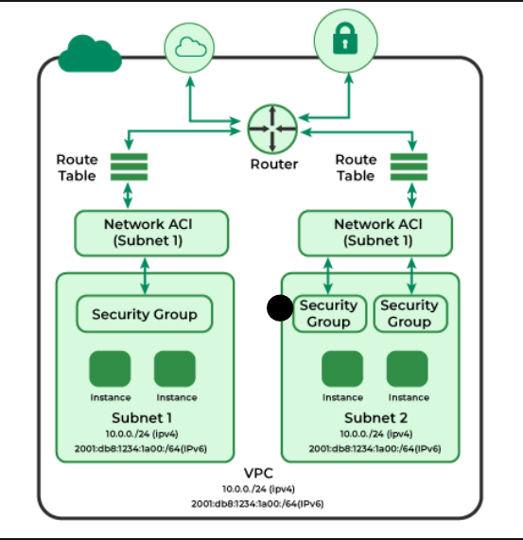
- Difference between public subnet and private subnet
Public Subnet – Users can access resources from the internet. Internet traffic is routed via internet gateway. Applications are stored in public subnet.
Private Subnet - Users cannot access resources from the internet. Internet traffic is routed via NAT gateway. Data is stored in private subnet (database, API calls)

VPC PEERING:
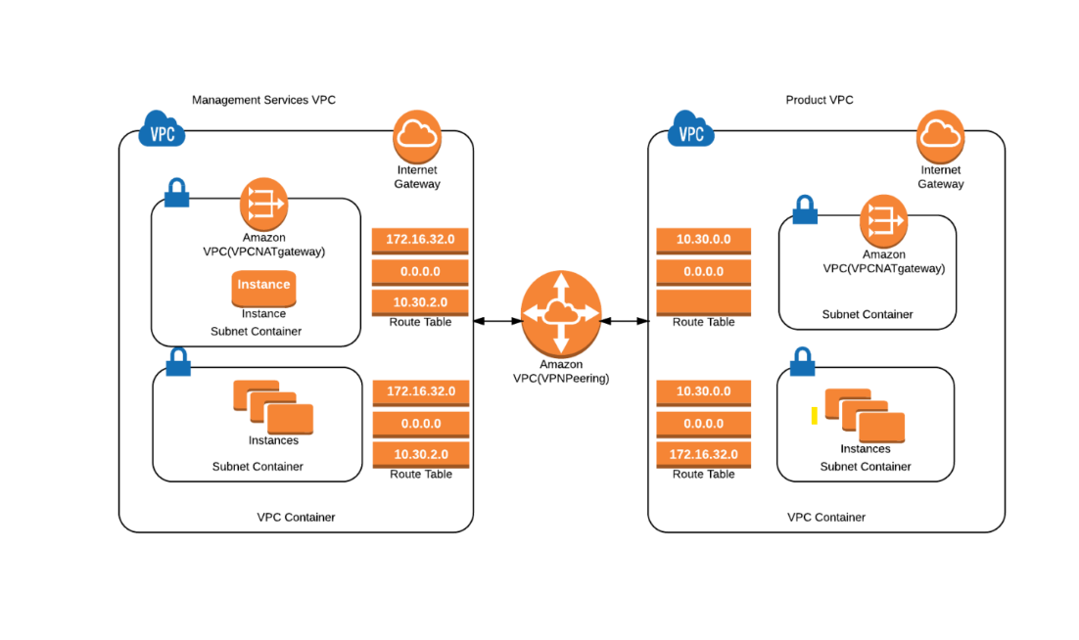
A VPC peering connection is a networking connection between two VPCs that enables you to route traffic between them using private IPv4 addresses or IPv6 addresses. Instances in either VPC can communicate with each other as if they are within the same network. You can create a VPC peering connection between your own VPCs, or with a VPC in another AWS account.
Types of VPC peering
- VPCs Peering same account and Region
- VPCs peering same account and different Regions
- VPCs peering different accounts and the same Region
- VPCs peering different accounts and Regions

1. General Conditions
- Both VPCs must have non-overlapping CIDR blocks.
- VPC peering is not transitive (i.e., if VPC A is peered with VPC B and VPC B is peered with VPC C, A cannot communicate with C unless an explicit peering connection is established).

✅ Allowed Peering (Non-Overlapping CIDRs)
- VPC A: 10.0.0.0/16
- VPC B: 192.168.1.0/24
❌ Not Allowed Peering (Overlapping CIDRs)
- VPC A: 10.0.0.0/16
- VPC B: 10.0.1.0/24 (overlaps with 10.0.0.0/16)

VPC PEERING LIMITATIONS:
There is a quota on the number of active and pending VPC peering connections per VPC. For more information
- You cannot have more than one VPC peering connection between two VPCs at the same time.
- Any tags that you create for your VPC peering connection are only applied in the account or Region in which you create them.
- You cannot create a VPC peering connection between VPCs that have matching or overlapping IPv4 CIDR blocks.
- You cannot create a VPC peering connection between VPCs that have matching or overlapping IPv6 CIDR blocks.
- VPC peering does not support transitive peering relationships. For example, if there are VPC peering connections between VPC A and VPC B, and between VPC A and VPC C, you can't route traffic from VPC B to VPC C through VPC A. To route traffic between VPC B and VPC C, you must create a VPC peering connection between them.
- You cannot create a security group rule that references a peer VPC security group

VPC Endpoints (AWS) - Definition
A VPC Endpoint allows secure and private connectivity between AWS services and your VPC without using the internet or a NAT gateway.

Types of VPC Endpoints
Type | Description | Example Services
Interface Endpoint | Uses AWS PrivateLink to connect to AWS services via an ENI (Elastic Network Interface) in your VPC. | S3, DynamoDB, SNS, SQS, API Gateway
Gateway Endpoint | Uses a gateway to route traffic to supported services without internet access. | Amazon S3, DynamoDB
Gateway Load Balancer Endpoint | Provides private access to third-party virtual appliances in your VPC via a GWLB. | Firewalls, Intrusion Detection Systems

Name | Default | Adjustable
Active VPC peering connections per VPC | 50 | Yes  (up to 125)
Outstanding VPC peering connection requests | 25 | Yes
Expiry time for an unaccepted VPC peering connection request | 1 week (168 hours) | No

